Qlik Sense Business Analyst Certification Guide

Visit Qlik Certification portal :

<https://www.qlik.com/us/services/training/certifications-and-qualifications>

Recommended Preparation Resources:

Qlik Continuous Classroom – [Business Analyst](http://qcc.qlik.com/course/view.php?id=284&section=1)

Sign in

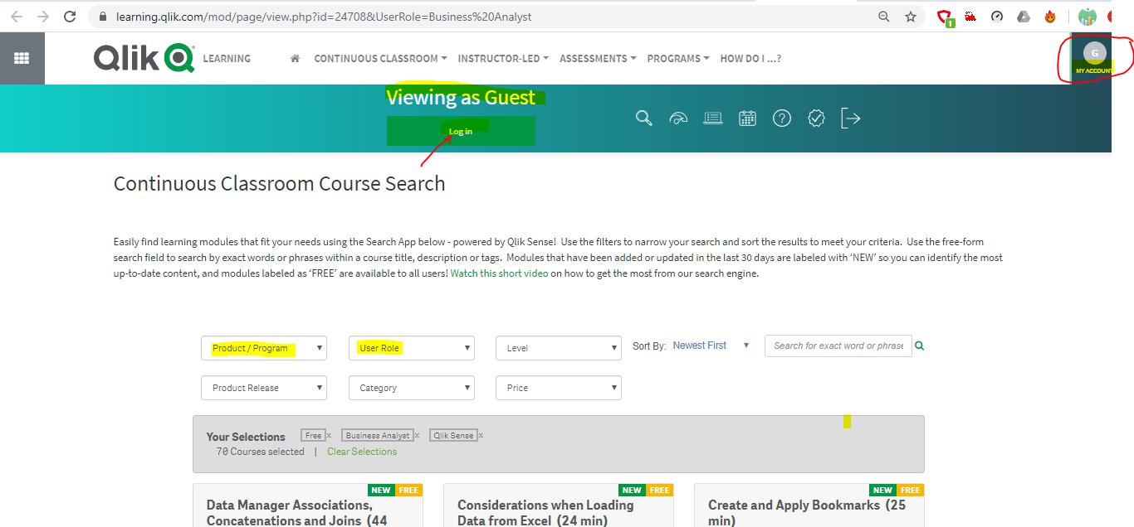

<https://learning.qlik.com/mod/page/view.php?id=24700#home> bookmark this page for learning.

After login🡪Continuous Classroom🡪Learning Plans🡪Business Analyst will help you to learn step by step.

Please ensure, to refresh the webpage before you study and ensure your login name on the right top corner.

***Please note: the Progress check boxes on the right should automatically be checked after clicking on each link below.  If the checkmarks do not appear, try refreshing your browser.***

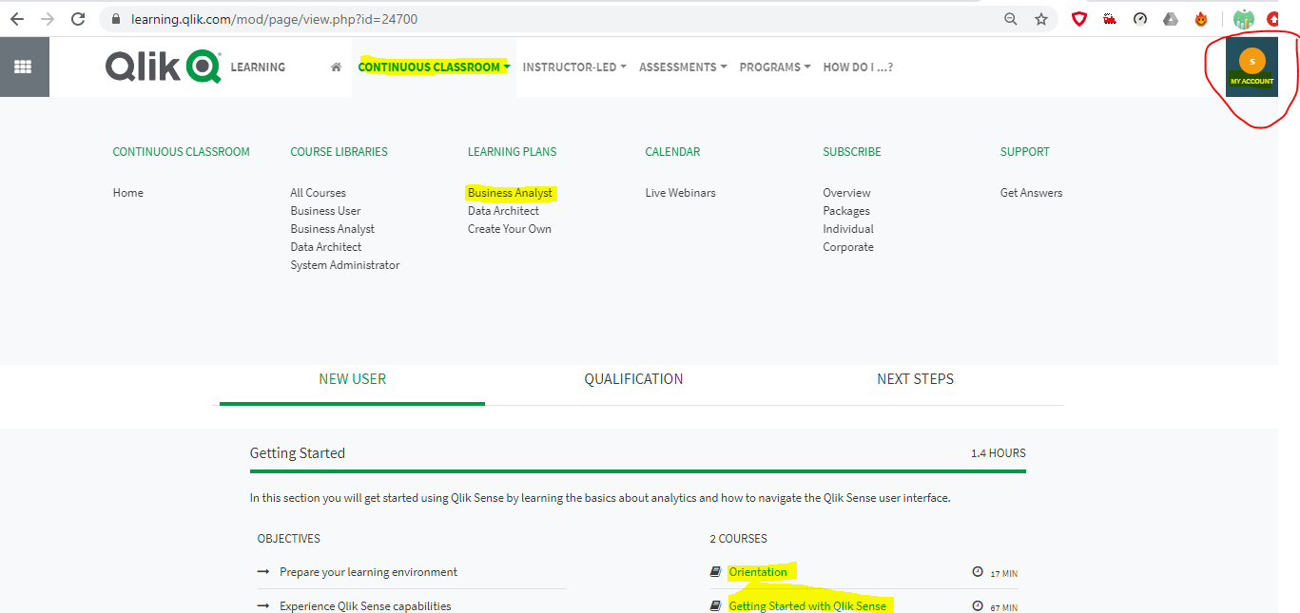

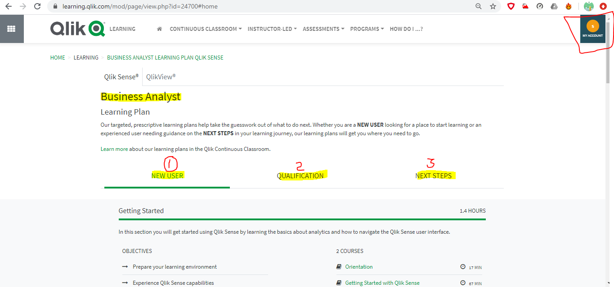

If you clicked all five you will get 100% status.

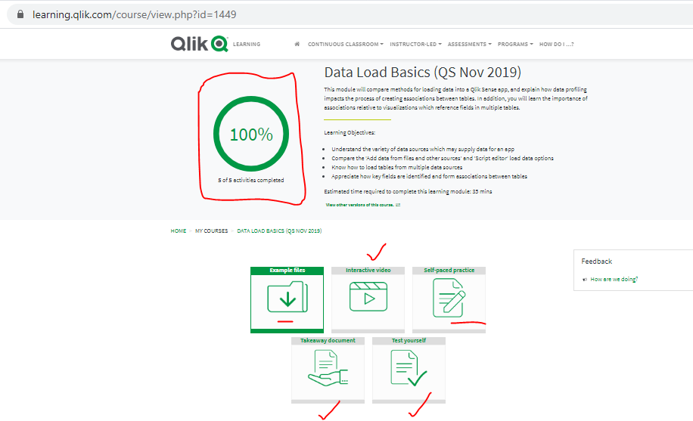

Select Business Analyst Role and complete all Category courses containing Business Analyst as mentioned below: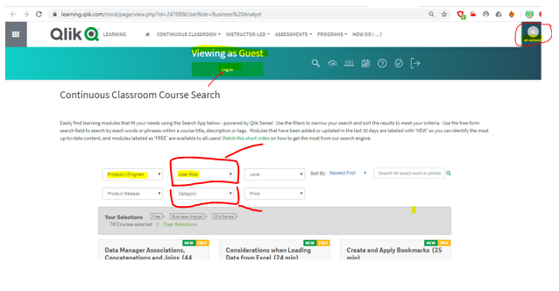

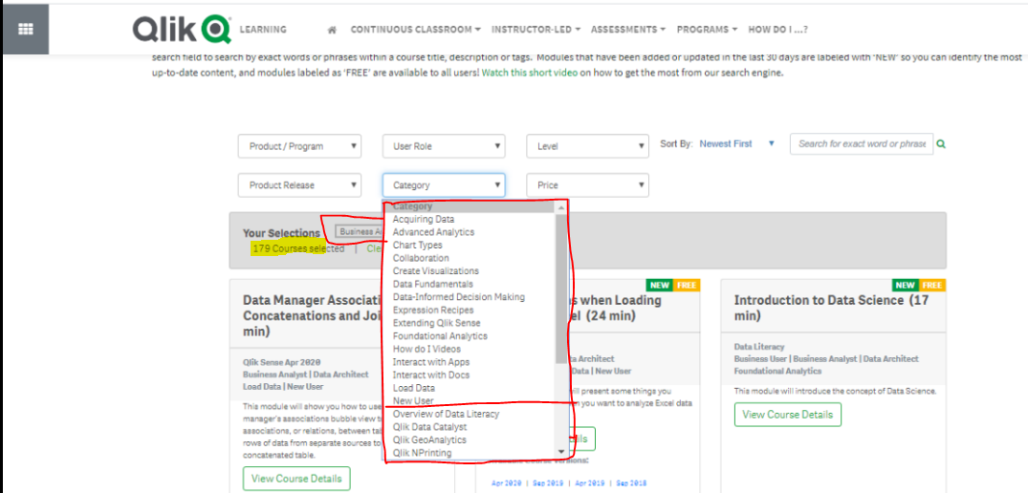

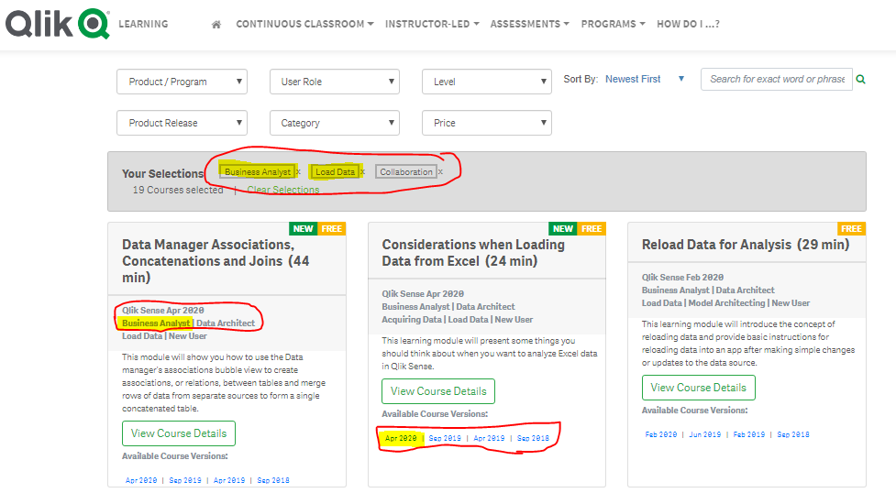

[Qlik Sense Certification Exam Study Guide](https://www.qlik.com/us/-/media/files/training/global-us/qlik-sense-certification-exam-study-guide-en.pdf?la=en):

<https://www.qlik.com/us/-/media/files/training/global-us/qlik-sense-certification-exam-study-guide-en.pdf?la=en>

FREE [Qlik Sense Business Analyst Certification Practice Questions](http://qcc.qlik.com/course/view.php?id=743&section=0):

<https://learning.qlik.com/course/view.php?id=743&section=0>

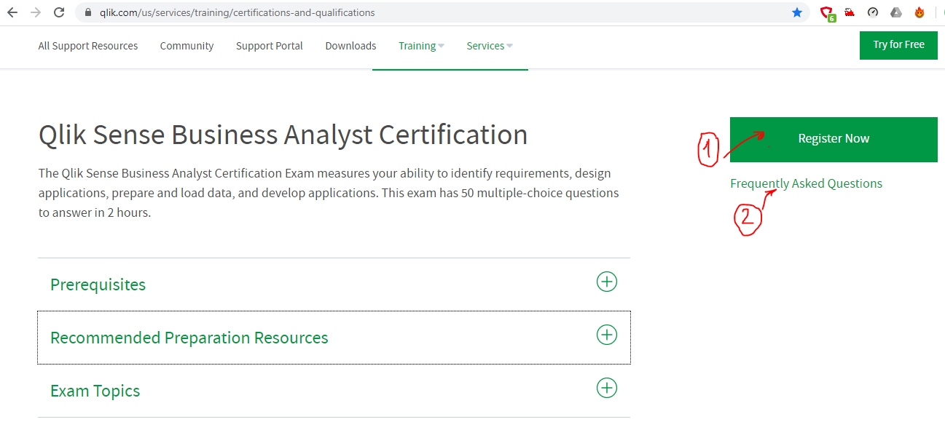

Exam FAQ :

<https://www.qlik.com/us/services/training/certifications-and-qualifications/faqs>

Exam Registration :

<https://home.pearsonvue.com/qlik>

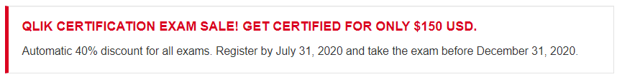

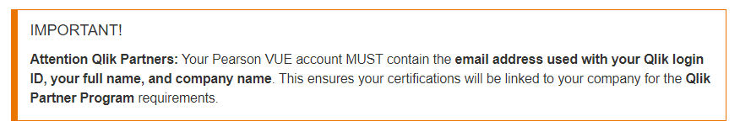

For help with exam registration, contact

<http://www.pearsonvue.com/qlik/contact/>

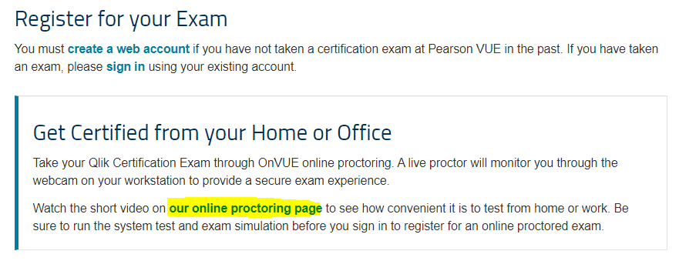

Online Proctoring Page:

<https://home.pearsonvue.com/qlik/onvue>

On Exam Date:

For online proctored exams, log in 15-30 minutes before your appointment. The proctor needs time to check you in, verify your photo ID, and make sure you have a completely clean workspace.

For online proctored exams, use the Scratch Pad in the exam delivery software.

[How long are the certification exams?](https://www.qlik.com/us/services/training/certifications-and-qualifications/faqs)

[Close](https://www.qlik.com/us/services/training/certifications-and-qualifications/faqs)

Qlik certification exams are 120 minutes. There will be a timer displayed on the top right side of the screen showing the remaining time. You will also be notified 15 minutes before the exam time ends.

[Can I re-take a certification exam?](https://www.qlik.com/us/services/training/certifications-and-qualifications/faqs)

[Close](https://www.qlik.com/us/services/training/certifications-and-qualifications/faqs)

Yes, if you do not pass an exam, you can re-take it as many times as you wish. Each re-take requires another payment of the exam fee at full charge.

Try to attend all the qns with any ans..dont leave any qns unanswered , there is no -ve marks, during exam u can mark the doubt questions and review at the end of the exam.

It was really tough..50MCQ scenario based paragraph 20qns with similar answer to choose with in 120 minutes ,58% is pass score, reading qns and choosing correct answer is takes more time for me,

Mostly all qns came under the exam study guide topics, so please focus the pdf exam guide for QS Business Analyst

Online exam rules from Pearson Vue:



